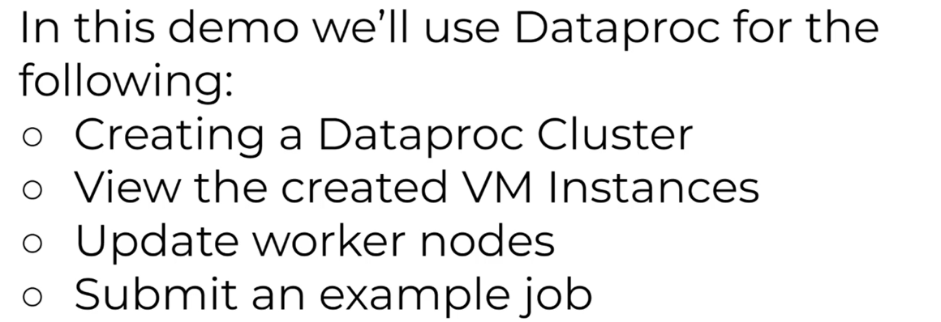

Dataproc > Create clusters > 1 master n workers >

VM instance > 1 master , 3 worker vm .

Go to cluster and edit worker nodes to 3 .

Create a spark job to run on created cluster .



Arguments - 1000